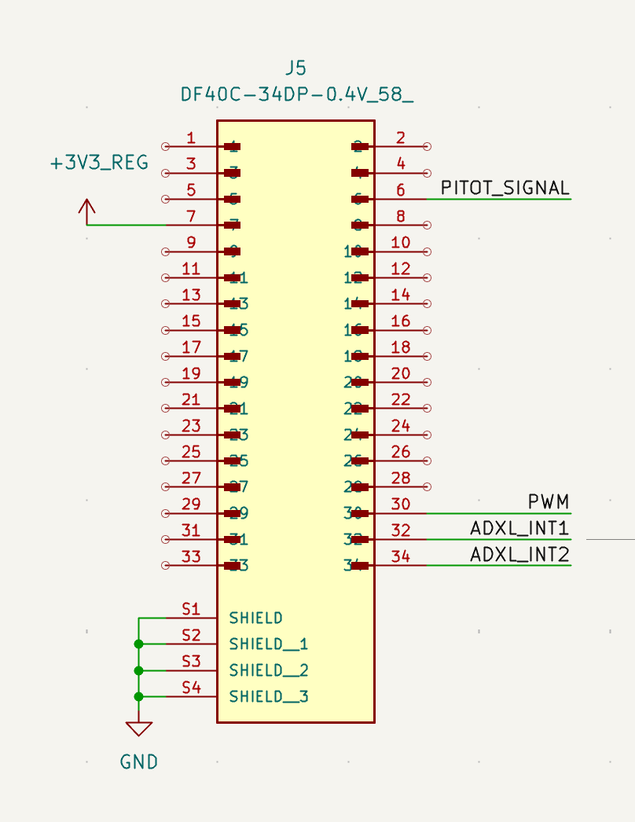
Page 1

Use the Digikey datasheet as reference: https://www.hirose.com/en/product/document?clcode=&productname=&series=DF40&documenttype=Catalog&lang=en&documentid=en_DF40_CAT
- The connector says 34 pins, and S1-S4 don’t seem to be among the 34 pins. Have you used these connectors before? Can these 4 be used as power/ground pins? Then are they listed as ‘SHIELD’?
- Is the 3V3_REG pin connected to the 3V3 Buck converter output, which has 3A output? Would this 3A be okay for this connector? The datasheet says 0.3A though.
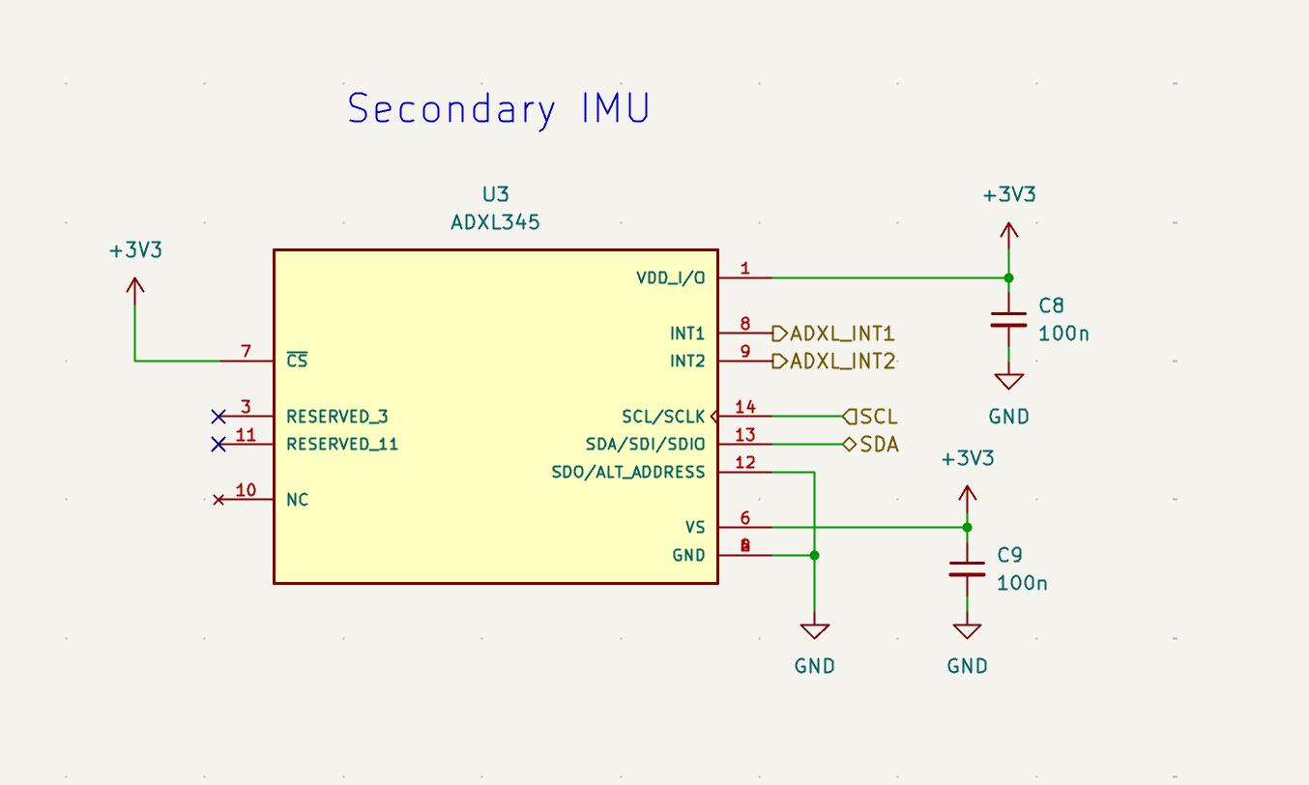
Page 2. Secondary IMU (U3)

I used the datasheet from analog devices: https://www.analog.com/media/en/technical-documentation/data-sheets/adxl345.pdf
Mainly Figure 40 on Page 17, since you are using I2C.
Please see below are my comments for this chip:
- Pin 7, power pin should be 3V3_REG, to be the same as Page 1. The same for Pin 1 and Pin 6, with 3V3, not 3V3_REG. Or are they supposed to connect to different 3.3V?
- Need external pull-up resistors, based on the description below Figure 40 on the datasheet. Do you have such resistors on the I2C pins? If not, add two, ~ 5k is fine.

Page 3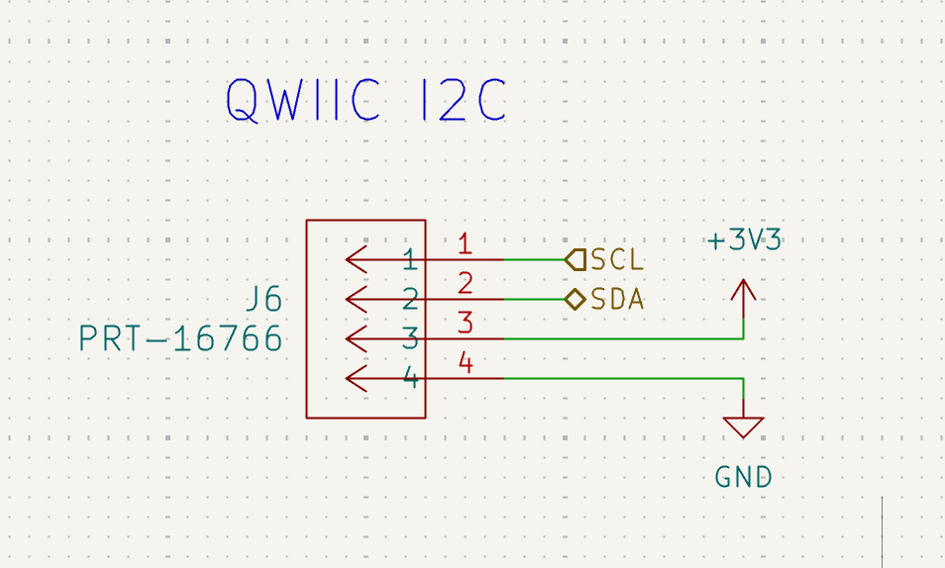
Is this 3V3 the same as the previous 3V3_REG? The same on the Pin6 of J10, it also says 3V3.
Why do you put a separate page for these two connectors?

Page 4.
1. Battery & Limit Switch
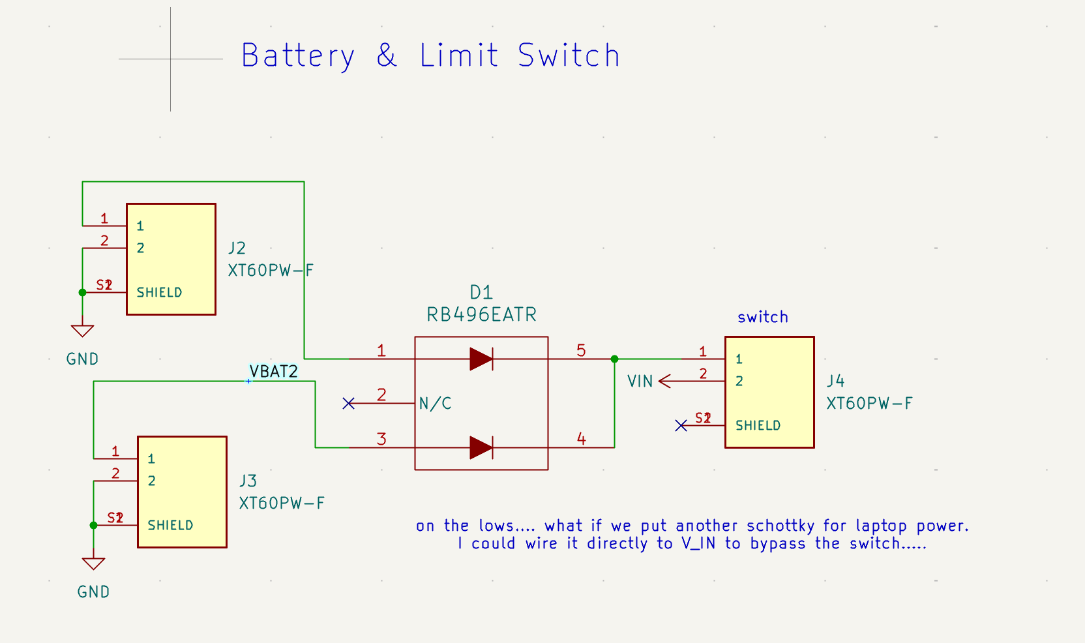
I used this datasheet: https://fscdn.rohm.com/en/products/databook/datasheet/discrete/diode/schottky_barrier/rb496eatr-e.pdf
Here are my comments:
- J2 and J3 are battery connector? Then missing VBAT1 for J2? Do you need them together to power the board, or either one?
- As said in your comment, the current rating is likely too low given the downstream parts it’s driving. The datasheet says only 1A. I think some calculation is needed here, so you know the power budget, and then based on that, choose a diode that could handle the current.

2. 3V3 Buck (U2)
Use the TI datasheet as the reference: https://www.ti.com/lit/ds/symlink/tps54302.pdf?ts=1783496645768
Mainly Figure 7-1 on Page 14, for input 8-28V, 5V output.
Please see below are my comments for this chip:
- Bootstrap cap C11 should directly connect Pin 6 and Pin 2(SW)
- R23 should be 49.9 ohms, not 49.9k

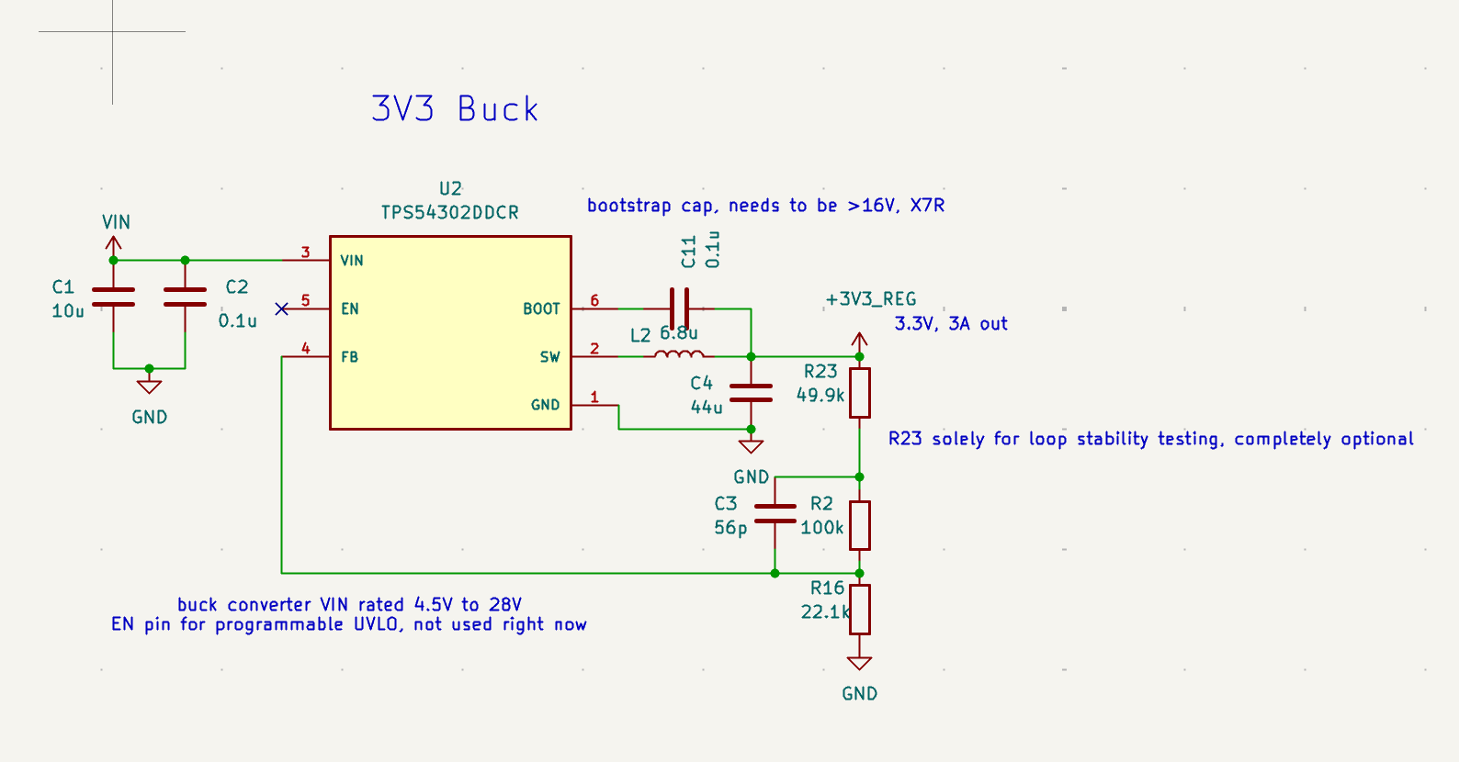
3. 6V Buck(U4)
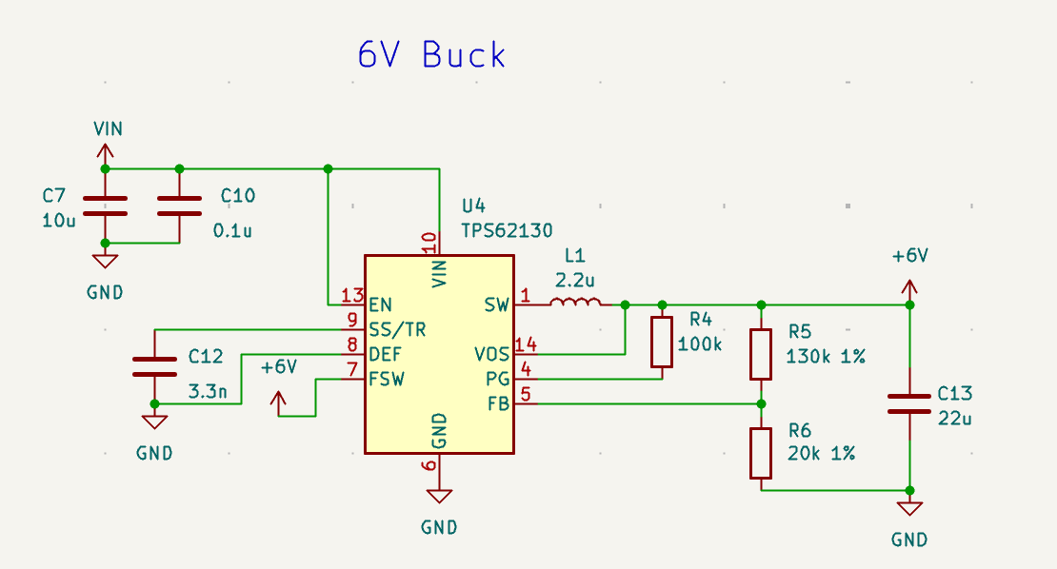
I used the TI datasheet: https://www.ti.com/lit/ds/symlink/tps62130.pdf?ts=1790000742168

Below are my comments for this chip:
- The input is 3-17V, which is significantly lower than the 3V3 Buck input 28V. What is the VIN from the batteries? Why not use the same chip for both?

